**Assignment 4**

21AIE111

Data Structure and Algorithms – SEM-II

Professor – Dr. Sachin Sir

Submitted By: Vikhyat Bansal [CB.EN.U4AIE21076]



1. Write a java code to generate 1 lakh random integer numbers between 1 and 1 lakh.

a) Collect it to an array.

b) Pick a number in the far end of the array

c) search that number and observe the time taken (in seconds)

(you can increase the total numbers to 10 lakh also).

CODE: [For 1 Lakh random numbers]

import java.util.Arrays;  
import java.util.Scanner;  
public class Search_Element {  
  
 public static void main( String[] args ) {  
 long start = System.currentTimeMillis(); //Start a counter to keep track of time.  
 int min = 1;  
 int max = 100000;  
 int n, x, flag = 0, i = 0;  
 Scanner s = new Scanner(System.in);  
  
 int[] arr = new int[1000001];  
 for ( i = 0; i < 100000; i++) {  
   
 int range = (max - min) + 1;  
 int randomNum = (int)(Math.random() * range) + min;  
 arr[i] = randomNum;  
 System.out.println(arr[i]);  
  
 }  
 System.out.println("Last element of array is: " + arr[99999]);  
  
 System.out.print("Enter the element you want to find:");  
 x = s.nextInt();  
 for( i = 0; i < arr.length; i++)  
 {  
 if(arr[i] == x)  
 {  
 flag = 1;  
 break;  
 }  
 else  
 {  
 flag = 0;  
 }  
 }  
 if(flag == 1)  
 {  
 System.out.println("Element found at position:"+(i + 1));  
   
 }  
 else  
 {  
 System.out.println("Element not found");  
 }  
   
 long end = System.currentTimeMillis();  
 System.out.println("Total Time taken by the program to execute is " +  
 ((end - start)/1000) + " seconds");  
   
 }  
}

OUTPUT:

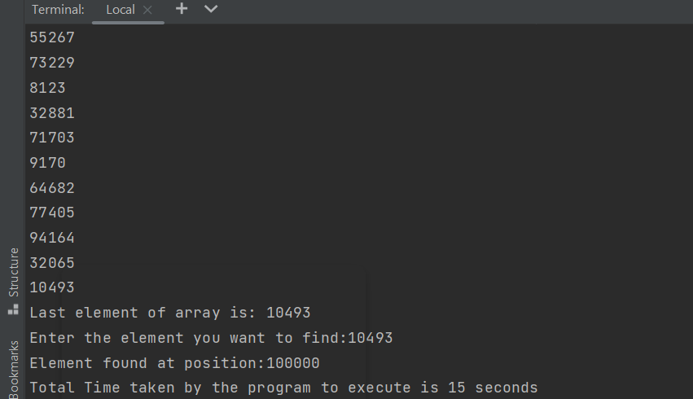

2. Write a java code to generate 1 lakh random integer numbers between 1 and 1 lakh.

a) Collect it to a single linked list.

b) Pick a number in the far end of the list (traverse the list)

c) search that number and observe the time taken (in seconds)

(you can increase the total numbers to 10 lakh also).

CODE:

import java.util.Random;  
public class LinkedRand {  
  
 static class Node{  
 int data;  
 Node next;  
 Node(int d) {  
 this.data = d;  
 this.next = null;  
 }  
 }  
 public Node head = null;  
 public Node tail = null;  
 public void insertNode(int d) {  
 Node object = new Node(d);  
 if(head == null) {  
 head = object;  
 }  
 else {  
 Node node = head;  
 while(node.next!=null) {  
 node = node.next;  
 }  
 node.next = object;  
 }  
 tail = object;  
 }  
 public static void printList(LinkedRand list)  
 {  
  
 Node node = list.head;  
  
 System.out.println("LinkedList: ");  
  
 // Traverse through the LinkedList  
 while (node != null) {  
 // Print the data at current node  
 System.out.println(node.data + " ");  
  
 // Go to next node  
 node = node.next;  
 }  
 }  
 public int retrieveLastElement() {  
 Node node = head;  
 while(node.next!=null) {  
 node = node.next;  
 }  
 System.out.println("Last element in linked list is:" +node.data);  
 return node.data;  
 }  
 public void findMatch(int t) {  
 Node node = head;  
 int count = 0;  
 while (node.next != null) {  
  
 if (node.data == t) {  
 System.out.println("Match of " + t + " found at location " + count);  
 }  
  
  
  
 if (count == 99999) {  
 System.out.println("Match of " + t + " found at location" + count);  
  
 }  
 count += 1;  
 node = node.next;  
 }  
 }  
  
 public static void main(String[] args) {  
 long start=System.currentTimeMillis();  
 Random obj = new Random();  
 LinkedRand list = new LinkedRand();  
 for(int i = 0;i <= 100000;i++) {  
 list.insertNode(obj.nextInt(100000));  
 }  
 *printList*(list);  
 int target = list.retrieveLastElement();  
 list.findMatch(target);  
  
 long end=System.currentTimeMillis();  
 float time=(end-start)/1000;  
 System.out.println("the time taken is "+(time)+" seconds");  
 }  
}

OUTPUT:

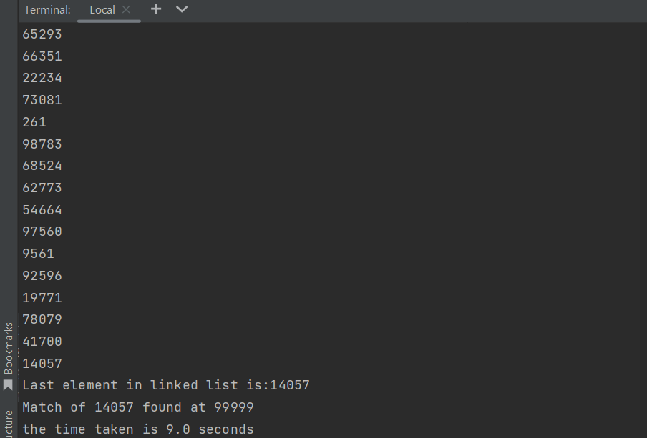

3. Write a java code to generate 1 lakh random integer numbers between 1 and 1 lakh.

a) Collect it to an array.

b) Pick 3 number in the far end of the array and create a sub-array

c) search the sub-array and observe the time taken (in seconds)

(you can increase the total numbers to 10 lakh also).

CODE: [For 1 lakh random numbers]

import java.util.Arrays;  
import java.util.Scanner;  
public class random {  
  
 public static void main( String[] args ) {  
 long start = System.currentTimeMillis(); //Start a counter to keep track of time.  
 int min = 1;  
 int max = 100000;  
 int x, flag = 0, i =0;  
 int k = 0;  
 int temp[] = new int[3];  
  
  
 int[] arr = new int[1000000];  
 for ( i = 0; i < 100000; i++) {  
   
 int range = (max - min) + 1;  
 int randomNum = (int)(Math.random() * range) + min;  
 arr[i] = randomNum;  
 System.out.println(arr[i]);  
  
 }  
 System.out.println();  
  
  
 int[] subarr = Arrays.copyOfRange(arr, 99997, 100000);  
 for (int p : subarr) {  
 System.out.print("Subarray of size 3 from initial array: " +p + " ");  
  
 System.out.println();  
  
 }  
 System.out.println();  
  
  
 for (int j = 0; j <arr.length-1; j++) {  
 for (int l = 0; l < 3; l++) {  
 if (arr[j] == subarr[0] && arr[j + 1] == subarr[1] && arr[j + 2] == subarr[2]) {  
 System.out.println("the element present in the array are: " +subarr[l]);  
 System.out.println("the location(index) at which all elements of subarray are: " +(((arr.length-1))-l));  
//  
 k = 1;  
 }  
  
 }  
 }  
 if (k==0) {  
 System.out.println("the subarray is not present in the array");  
 }  
  
  
 long end = System.currentTimeMillis();  
 System.out.println("Total time taken by the program to execute is: " +  
 ((end - start)/1000) + " seconds");  
  
  
 }  
}

OUTPUT:

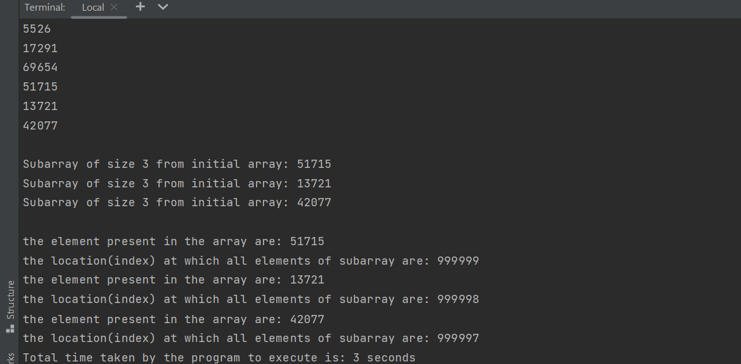

4. Write java code to find the possible substrings (size of substring is atleast 2) from the given sequences

a) ATGCT b) AGCT

a) CCGTCG b) CCGCG

CODE: a)

public class Searchsub {  
 public static void main(String[]args) {  
 String arr[]= {"A","T","G","C","T"};  
 String subarr[]= {"A","G","C","T"};  
 String temp[]= new String[2];  
 String temp2[]= new String[3];  
 for (int i = 0; i <arr.length-1; i++) {  
 for (int j = 0; j <3 ; j++) {  
 if (arr[i]==subarr[j] && arr[i+1]==subarr[j+1]) {  
 System.out.println("common seqence with two elements");  
 for (int k = 0; k <temp.length; k++) {  
 temp[k]=subarr[j+k];  
 System.out.println(temp[k]);  
 }  
 break;  
 }  
 }  
 }  
 for (int i = 0; i <arr.length-2; i++) {  
 for (int j = 0; j <2; j++) {  
 if (arr[i]==subarr[j] && arr[i+1]==subarr[j+1] && arr[i+2]==subarr[j+2]) {  
 System.out.println("the common seqence with three elemets");  
 for (int k = 0; k <temp2.length; k++) {  
 temp2[k]=subarr[j+k];  
 System.out.println(temp2[k]);  
 }  
 break;  
 }  
 }  
 }  
 }  
}

OUTPUT: a)

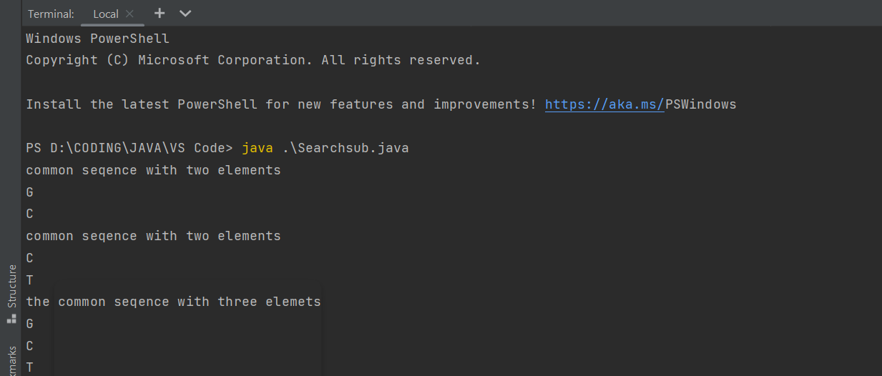

b)

public class Searchsub {  
 public static void main(String[]args) {  
 String arr[]= {"C","C","G","T","C","G"};  
 String subarr[]= {"C","C","G","C","G"};  
 String temp[]= new String[2];  
 String temp2[]= new String[3];  
 for (int i = 0; i <arr.length-1; i++) {  
 for (int j = 0; j <4 ; j++) {  
 if (arr[i]==subarr[j] && arr[i+1]==subarr[j+1]) {  
 System.out.println("common seqence with two elements");  
 for (int k = 0; k <temp.length; k++) {  
 temp[k]=subarr[j+k];  
 System.out.println(temp[k]);  
 }  
 break;  
 }  
 }  
 }  
 for (int i = 0; i <arr.length-2; i++) {  
 for (int j = 0; j <3; j++) {  
 if (arr[i]==subarr[j] && arr[i+1]==subarr[j+1] && arr[i+2]==subarr[j+2]) {  
 System.out.println("the common seqence with three elemets");  
 for (int k = 0; k <temp2.length; k++) {  
 temp2[k]=subarr[j+k];  
 System.out.println(temp2[k]);  
 }  
 break;  
 }  
 }  
 }  
 }  
}

OUTPUT: b)

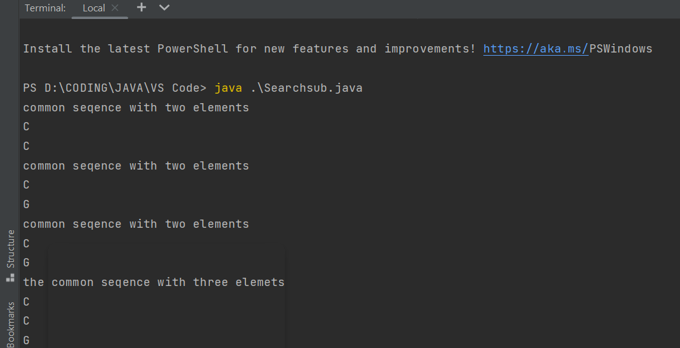

Mention machine specifications like OS, RAM, GPU

